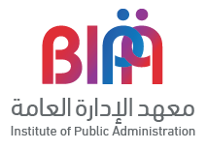

Even though the women workers in the Public Sector in The Kingdom of Bahrain outnumber their men colleagues, they still concentrated at the lower part of the hierarchy, leaving the top managerial levels to be occupied by their men colleagues. This research has investigated the reasons behinds that and listed the challenges that lead to such situation. At the end the analysist of both primary and secondary data have resulted in the construction of a Women Career Progression Model

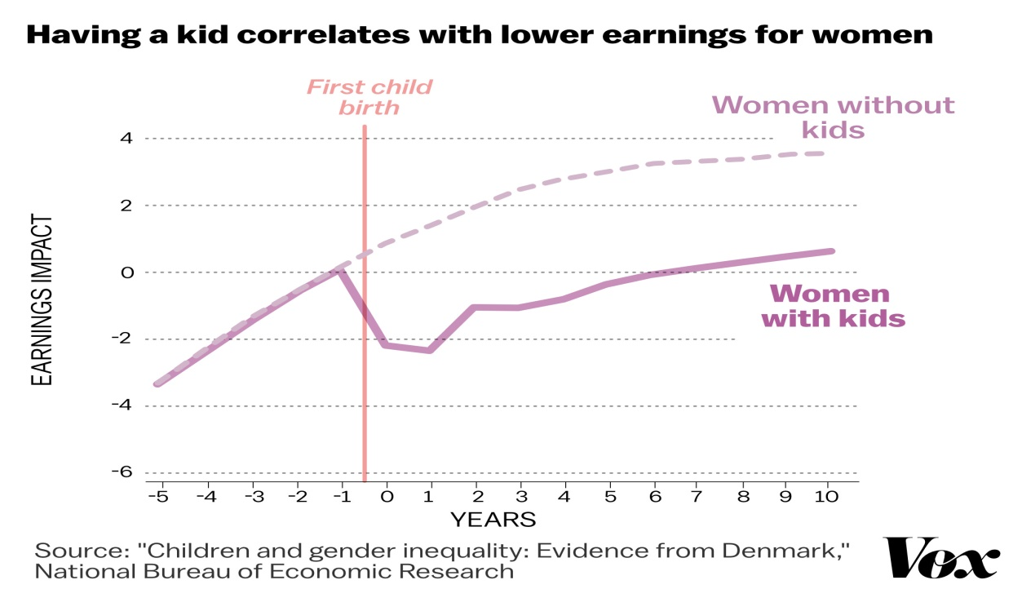

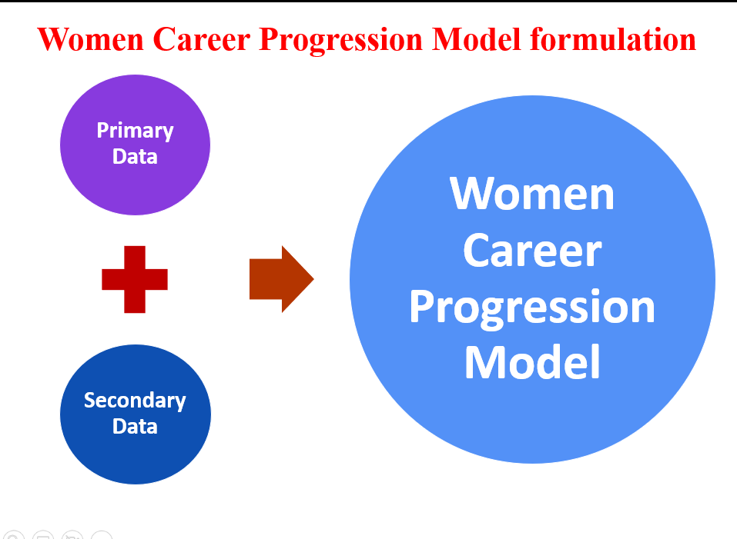

**OVERVIEW**

**THE CHALLENGES FACING BAHRAINI WOMEN IN BEING APPOINTED TO HIGH MANAGERIAL POSITIONS IN THE PUBLIC SECTOR: THE “GLASS CEILING”**



**PROBLEM**

The research problem can be summarized in the following question: “What are the challenges facing Bahraini women through career progression to C level in public sector in Kingdom of Bahrain?”

The two sub questions are:

* + What are the challenges that facing Bahraini women through career progression in public sector to reach C level?
  + What are the factors that would help Bahraini women to break the Glass Ceiling in public sector?



**METHODOLOGY**

This research was based on a Qualitative, as secondary data was gathered through nine the semi structured interviews with Bahraini Women succeeded to make it to the C-level in the public sector. Both primary and secondary data have been interpreted and analyzed, to come out with a conclusion for this research that answered the research questions.



**FINDINGS**

It has been concluded that the challenges that facing Bahraini women through career progression in public sector are:

* The Organizational Culture
* The lack of Mentorship and Sponsorship within the public sector.
* Having young children who needs care at early years of their lives.
* Lack of laws and regulations that handles inequality at workplaces at the public sector.
* Unfair competition and jealousy.
* Rivalry from boss especially when the manager is a woman (Queen Bee Phenomenon).

factors that would help Bahraini women to break the Glass Ceiling in the public sector are as:

Personal Traits, Organizational Culture, Society, Culture and Religion, Government Efforts (Supreme Council for Women) and International Bodies



* Ensuring transparency within the Public Administration especially through the promotion process.
* promote the practice of Mentoring and Sponsorship within the public organizations.
* Interdicting Maternity Insurance Schema to cover both Public and private sector.
* Improve the Quality of Data available for Bahraini Working Women through SIO & IGA.
* National Audit Office, takes the mandate of investigating the Gender Pay Gap in all the Public Organizations that are being audited.
* Establishment of nurseries within the big public organizations within their buildings to solve one of the biggest challenges that faces working women at the public sector.
* launching of awareness campaigns, to emphasize on women productivity and the importance of gender diversity.
* Ministry of Education enrich, their educational curriculum with materials that aims to improve the social attitude toward women, and their role in the community.
* Establish a unit within the Supreme Council for Women to register and investigate unfair treatments or discrimination cases against women in the public sector.

**RECOMMENDATIONS**